**Green Survey Results 2024/25**

This survey was completed by 209 students across 2 weeks to find out their thoughts and views on the waste management around the university, their accommodation, and general lives.

**Section 1**

**How much do you agree with the following statements?**

On a scale of extremely disagree (0) to Very Much Agree (5)

1. *I go out of my way to recycle while out and about……*

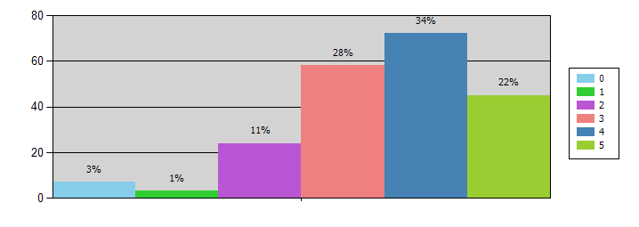

|  |  |  |
| --- | --- | --- |
| **Response** | **Count** | **%** |
| 3 | 58 | 27.75% |
| 4 | 72 | 34.45% |
| 5 | 45 | 21.53% |
| 2 | 24 | 11.48% |
| 0 | 7 | 3.35% |
| 1 | 3 | 1.44% |
|  | 209 |  |

As you can see 34% of students try to recycle when they are out and about.

1. *I feel recycling won’t change the environment…………*

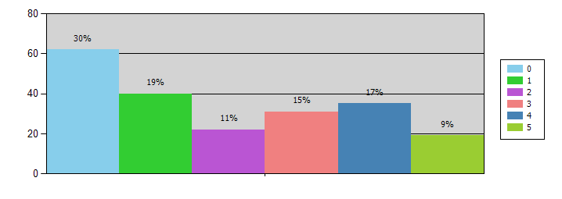

|  |  |  |
| --- | --- | --- |
| **Response** | **Count** | **%** |
| 0 | 62 | 29.67% |
| 1 | 40 | 19.14% |
| 3 | 31 | 14.83% |
| 4 | 35 | 16.75% |
| 5 | 19 | 9.09% |
| 2 | 22 | 10.53% |
|  | 209 |  |

49% of students disagree with this statement responding with a 0 or 1

1. *I feel that if the university/company does not advertise the use of recycle bins, why would I recycle?*

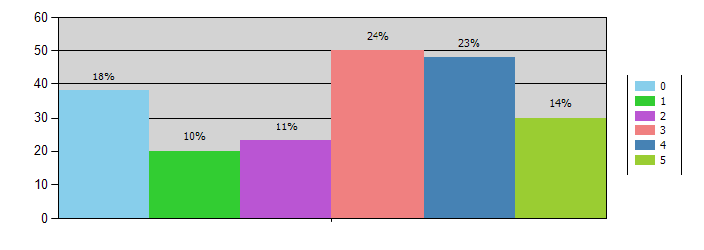

|  |  |  |
| --- | --- | --- |
| **Response** | **Count** | **%** |
| 5 | 30 | 14.35% |
| 3 | 50 | 23.92% |
| 0 | 38 | 18.18% |
| 2 | 23 | 11.00% |
| 1 | 20 | 9.57% |
| 4 | 48 | 22.97% |
|  | 209 |  |

37% of students agree that the university does not advertise the use of the recycling bins responding with a 4 or 5

1. *I am aware of the consequences for the planet of using single use plastics.*

|  |  |  |
| --- | --- | --- |
| **Response** | **Count** | **%** |
| 3 | 42 | 20.10% |
| 4 | 76 | 36.36% |
| 5 | 69 | 33.01% |
| 2 | 8 | 3.83% |
| 1 | 14 | 6.70% |
|  | 209 |  |

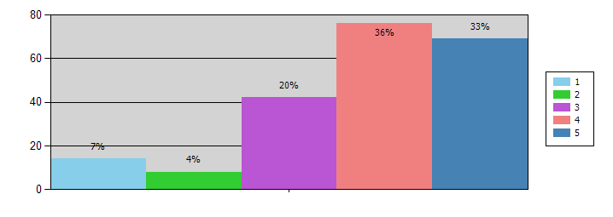

69% of students understand the consequences of single use plastics.

1. *Until Big Corporations do their bit my input won't make a difference.*

|  |  |  |
| --- | --- | --- |
| **Response** | **Count** | **%** |
| 4 | 55 | 26.32% |
| 3 | 52 | 24.88% |
| 0 | 22 | 10.53% |
| 5 | 35 | 16.75% |
| 2 | 28 | 13.40% |
| 1 | 17 | 8.13% |
|  | 209 |  |

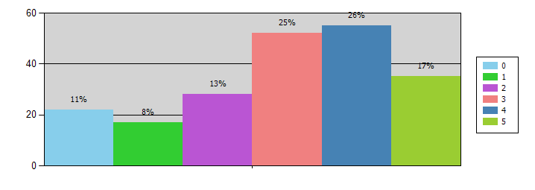

43% of students feel that their small input wont have an effect until the Big corporations start reducing their own carbon emissions, through various schemes.

1. *I go out of my way to Recycle at home ….*

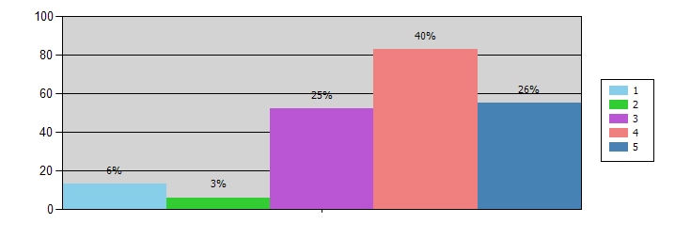

|  |  |  |
| --- | --- | --- |
| **Response** | **Count** | **%** |
| 4 | 83 | 39.71% |
| 3 | 52 | 24.88% |
| 5 | 55 | 26.32% |
| 1 | 13 | 6.22% |
| 2 | 6 | 2.87% |
|  | 209 |  |

Over half of the students recycle at home regularly.

**Section 2**

**All the following questions are answered :Yes or No**

1. *Do you feel the university provides enough recycling bins on campus? Yes or No*

|  |  |  |
| --- | --- | --- |
| **Response** | **Count** | **%** |
| No | 77 | 37.56% |
| Yes | 128 | 62.44% |
|  | 205 |  |

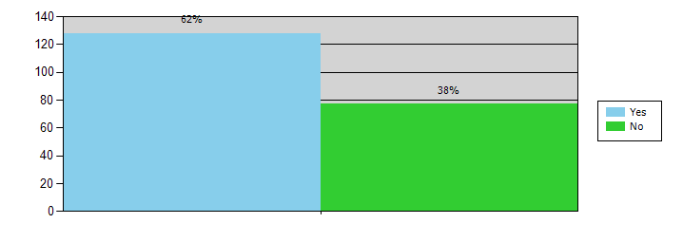

The majority of students feel the university provides recycling bins

1. *Do you recycle in your household – Private or Halls? Yes or no*

|  |  |  |
| --- | --- | --- |
| **Response** | **Count** | **%** |
| Yes | 171 | 82.21% |
| No | 37 | 17.79% |
|  | 208 |  |

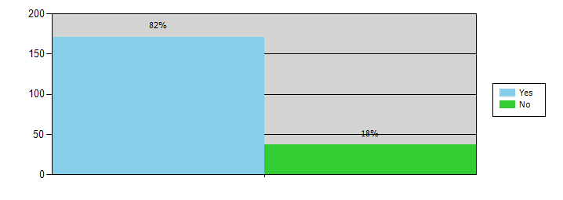

82% of students recycle in their households

1. *If you live in Halls, do you think there is enough opportunity to recycle? Yes or No*

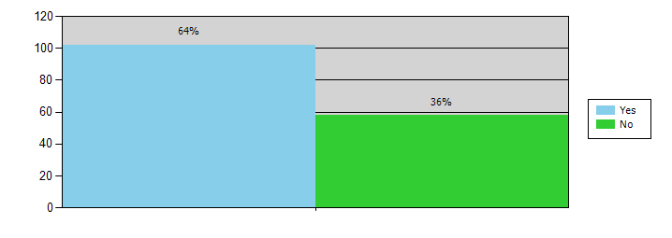

|  |  |  |
| --- | --- | --- |
| **Response** | **Count** | **%** |
| No | 58 | 36.25% |
| Yes | 102 | 63.75% |
|  | 160 |  |

64% of Students feel they have the opportunity to recycle.

1. *Do you feel you would know which bins to put in different items? Yes or no*

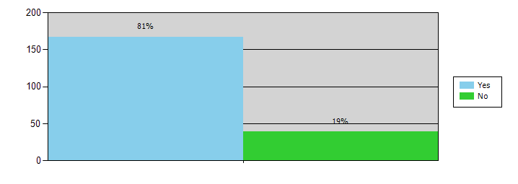

|  |  |  |
| --- | --- | --- |
| **Response** | **Count** | **%** |
| Yes | 167 | 81.07% |
| No | 39 | 18.93% |
|  | 206 |  |

The majority of students know which bins are for specific items

1. *Are you aware that food waste should go into a different bin from all the other recyclable items? Yes or no*

|  |  |  |
| --- | --- | --- |
| **Response** | **Count** | **%** |
| Yes | 175 | 84.54% |
| No | 32 | 15.46% |
|  | 207 |  |

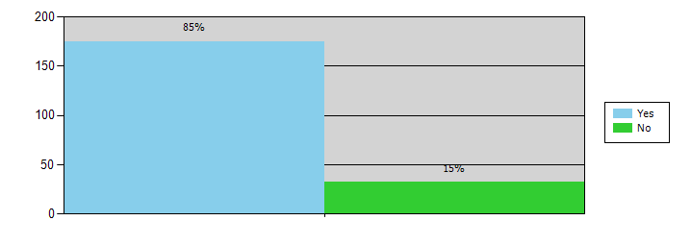

85% of students are aware that food waste should be recycled separately to other recyclable items

1. *Do you use the food waste bins in the lounge and beeches? Yes or no*

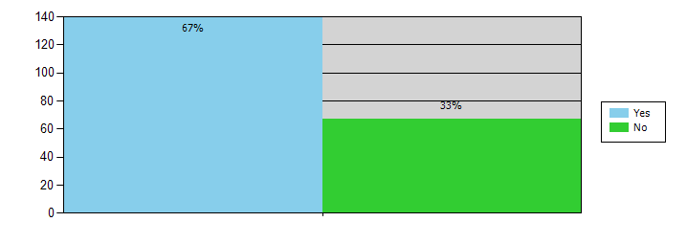

|  |  |  |
| --- | --- | --- |
| **Response** | **Count** | **%** |
| No | 67 | 32.52% |
| Yes | 139 | 67.48% |
|  | 206 |  |

Over half of the students have used the specific food waste bins in the Cafés and Bars in the university.

1. *Do you think clearer signage would help people recycle? Yes or No*

|  |  |  |
| --- | --- | --- |
| **Response** | **Count** | **%** |
| Yes | 178 | 86.41% |
| No | 28 | 13.59% |
|  | 206 |  |

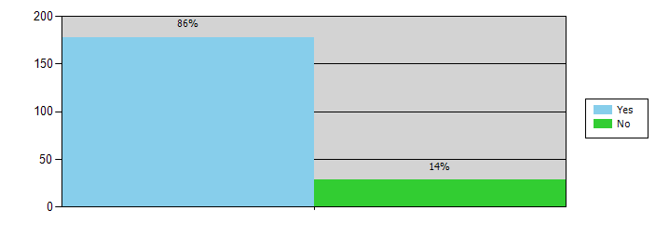

The majority of students feel the signage for the recycling bins needs to be clearer.

1. *Do you avoid buying plastic bottles and use a refillable bottle instead? Yes or No*

|  |  |  |
| --- | --- | --- |
| **Response** | **Count** | **%** |
| Yes | 132 | 64.39% |
| No | 73 | 35.61% |
|  | 205 |  |

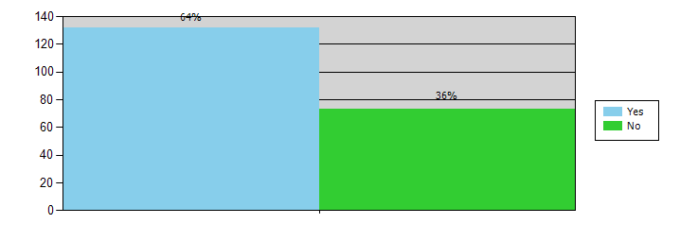

64% of the student body use a refillable water bottle instead of buying a plastic bottle.

1. *As part of the Green Campaign, we will be encouraging students to recycle. Would you be interested in being part of the campaign? Yes or No*

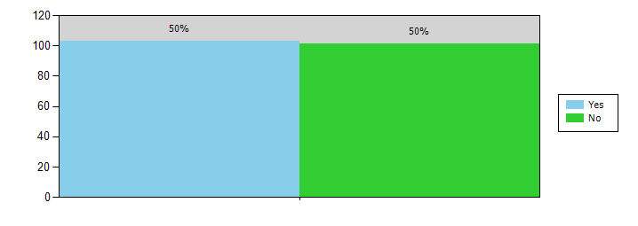

|  |  |  |
| --- | --- | --- |
| **Response** | **Count** | **%** |
| Yes | 103 | 50.49% |
| No | 101 | 49.51% |
|  | 204 |  |

Half of the students whom where questioned said they would be interested in getting involved with the Green campaign regarding waste management.

1. *If you live in Halls, do you think it would be helpful to have a bin just for food waste?*

|  |  |  |
| --- | --- | --- |
| **Response** | **Count** | **%** |
| YES | 86 | 54.78% |
| N/A | 51 | 32.48% |
| NO | 20 | 12.74% |
|  | 157 |  |

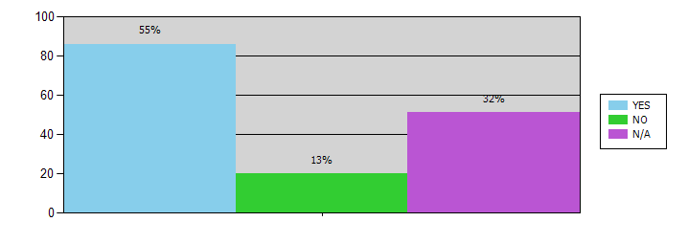

Just over half of students feel that a specific food waste bin in halls would be helpful to help with recycling while at university.

After running this survey, we feel the student voice is clear that although they know about recycling and will recycle if the opportunity arises, the signage is needs to be clearer.

This Survey has formed the base of the Waste Not, Want Not! campaign and has been shared with the Head of Sustainability in the university, the Elected Officers at the Students’ Union and the Green Ambassadors.

* The campaign will focus on the use of the food waste bin and breaking apart the other recyclable items into the correct bins.
* Making the signage clearer and more visually appealing to all who use the Cafes and Bars in the university.
* General awareness of the effects of not recycling
* What is and isn’t recyclable
* This campaign is student led by the Green ambassadors and volunteers.