Big Conversation 2024 analysis
Introduction
Throughout enrolment week this year, operating on a condensed period across two days, Union staff and freshers’ helpers were present to meet with new students individually to give a personal welcome to the Students’ Union and to capture some basic data. For the first time, the Big Conversation was run separately at the Uxbridge Campus during their main day of enrolment.
Data captured throughout the discussions included awareness of the Students’ Union and Big Deal, prior to arrival, and to gain some basic insights into what students were most looking forward to. In contrast, we also gathered data on student concerns and to understand where some of the key challenges might lie for students.
Throughout the week, staff managed to hold a total of 921 conversations, which represents a drastic increase in comparison to last year (+64.47%). As part of these discussions, staff collected student ID numbers and this data has been fed into our recording systems as a record of initial engagement with the Students’ Union (a demographic overview is included within Appendix 1). Although we noted a major increase in responses this year, running the Big Conversation did present a challenge with the number of staff trying to process students. Throughout most of the two main enrolment days, large queues formed with students waiting to speak to members of staff. Next year, we will be putting in place more targeted plans and to look at having considerably more staff available to run the project. Admittedly, the new space at the back of The Atrium does work well and there is ample space to have more desks and space available to speak directly to students.
Analysis of initial questions
At the start of the discussions, we asked students two simple questions on membership and the Big Deal with the below findings (the numbers in brackets denote the percentage differences to 2023). It is worth pointing out that we have noted positive improvements in the findings for each question, in comparison to last year (an increase of 4.52% and 5.08% respectively).
Q2. Did you know that you are a member of the Students’ Union?
Yes | 72.20% (+4.52%)
No | 27.80%
Base (all respondents): 921
2023
Yes | 67.68%
No | 32.32%
Base (all respondents): 560
Q3. Have you heard about the Big Deal?
Yes | 57.33% (+5.08%)
No | 42.67%
Base (all respondents): 921
2023
Yes | 52.25%
No | 48.75%
Base (all respondents): 560
Analysis of open comments
Q4. captured insights into what students were most looking forward to at university. Responses to this question were gathered through open comments, where members of the team were asked to briefly contextualise feedback from individuals. The open comments were then analysed, grouped together to identify broader themes and then coded in a way to create sub-themes.
On analysing the data, a limited number of students responded to this question with an ‘unsure’ response or gave no answer. Filtering out these non-responses, leaves a cleaned total of 828 responses to this question.
Conducting a thematic analysis of the data, the following four themes emerged:
- University and academic experience
- Life skills and interpersonal qualities
- Students’ Union and co-curricular activities
- Achieving and the future self
University and academic experience
The strongest theme, with 447 (54%) responses, covered academic and the broader university experience. In line with previous years, this follows suit with the experience of coming to university being the strongest theme. Within this theme, students were able to describe how they were looking forward to learning, expanding and gaining knowledge into their chosen course or subject. Some students mentioned the ability to gain experience in a certain field. Ohers expressed their eagerness for the overall student experience, “being here”, alongside “enjoying student life”, university life and the lifestyle that comes alongside studying in higher education.
This theme also encompassed responses where students noted general excitement and keenness to get started with the course. Others indicated how they were looking forward to being part of a wider University community and the opportunity to network with other students. Following on from this, several students noted their eagerness to be able to meet with industry professions and the potential to network with individuals or companies beyond the University community. Finally, a smaller number of responses mentioned the University facilities, and the use of “technology in the course”, alongside location, where Pinewood Studios was explicitly mentioned.
Life skills and interpersonal qualities
The second strongest theme, with 316 (38%) responses, encompasses the wish to build new life skills, grow interpersonal qualities and develop other soft skills. In comparison to last year, this theme, generally, has been much stronger this year and this was evident throughout discussions with students (last year, this was themed as ‘making friends and enhancement of personal qualities’ and was the third strongest theme with 24%). Within this theme, the most prevalent response mentioned some form of friendship – both in terms of meeting new people, making new friends and the willingness to create lifelong friendships. To get to this point, students acknowledged the fact that they need to socialise with other groups of students and to look at expanding and joining new friendship circles or “broadening social networks.” In addition, some students noted how they were looking forward to interacting with different cultures and experiences, for instance, “meeting new people from different countries and learning about new cultures.”
A number of students simply stated how they were looking forward to enjoying “everything” or the entire experience, covering all aspects of starting at university and not being to pin-point one specific aspect. Conversely, one student was able to note the juxtaposition of being “excited and nervous for everything.”
Unsurprisingly, many students suggested the independence and freedom that university offers and the ability to live away from home. Others suggested how they wanted to use the time at university to develop as an individual, recognising the want to build new personal traits, such as leadership, new skills and “developing creatively”. Others were, perhaps, slightly more introspective in their quest, with an aim to “finding sense of self”, “developing a sense of security”, pushing their limits and recognising the start of the “next phase of life.”
Some students noted the fact that coming to university is doing something new and offers the ideal opportunity to try new experiences and new things. A small number simply mentioned the opportunity to come to university with the aim to have fun.
Students’ Union and co-curricular experiences
Although this has shifted position in comparison to last year, what we offer as a Students’ Union, and the broader co-curricular experiences offered at university, received a total of 163 (20%) responses (2023: 37%). The vast majority of those that responded to co-curricular activities mentioned their want to join sports teams, clubs and societies. Of those that mentioned clubs and societies, a large percentage were able to specifically mention which ones they wanted to join, possibly indicating that they had researched what was available prior to arriving at BNU. One student was able to mention Sport for Fun, whereas another suggested how they were looking forward to “societies and exploring things based on their course.”
Students also mentioned how they were excited for Freshers’ Fortnight and all the events and activities that we host across the first few weeks of term and then into the academic year. A small number of students mentioned getting involved as a rep, with one student saying how they were “part of the SU in Nigeria, [and] really wants to be involved and engage.”
Some students cited their eagerness to get involved in the wider University community and taking part in fun activities across campus and beyond. A small number mentioned additional co-curricular activities, such as fitness, going to the gym and running.
Out of those that mentioned activities through the Students’ Union, several were able to cite how the activities were free to take part in. From free sport and club nights to free additional skills training, several students understood the fact that there is no cost involved to participate. Out of those that we spoke to, a few did not realise that it was free and they were impressed to learn more about the Big Deal.
Achieving and the future self
This has been created as a new theme this year as it featured more prominently in the analysis compared to previous years. There were also certain parts of this that made it feel more like its own theme, with 43 (5%) responses. Of those that responded in this way, the majority explained their aim to building a career and to get a degree, with their sights set on graduating and getting a qualification. Several mentioned the fact that they were back learning again, either after a break or for further study (e.g., a master’s degree).
Several students explained how they were aiming for a “first class degree, making family proud”, and a small number stated their pride in being the first in the family to go to university. Others referenced how they were aiming to achieve goals with a small number studying due to a career change. One student noted how they are coming to BNU so they are “getting to where I want to be.” Others talked about the opportunity to study a passion and to improve knowledge into their career. A small number cited, simply, “getting somewhere in life” and “getting it done.”
The above themes and sub-themes have been captured into the following thematic map.
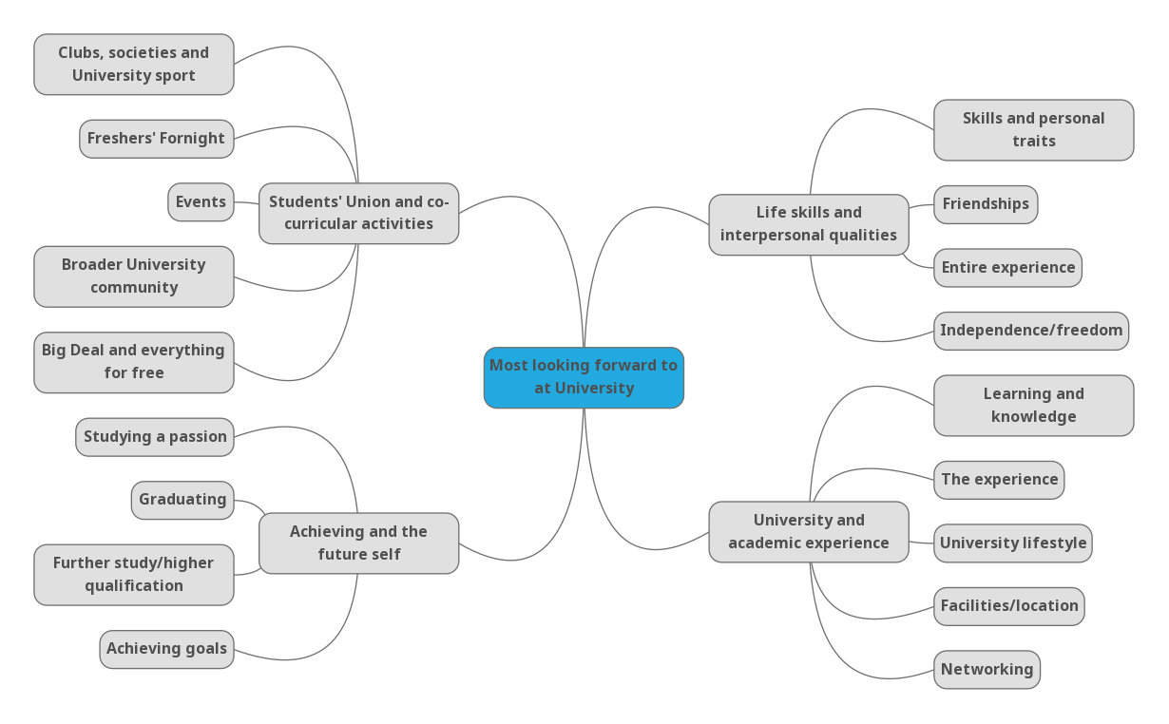

Q5. captured student feedback into some of the challenges and concerns that students might have about starting university. Responses to this question were also obtained through discussions with individuals and gathered through open comments. These comments were then grouped together around common themes and sub-themes.
From the subsequent analysis, a large proportion of students noted that they had no concerns or opted to leave the question blank, to leave a total of 262 cleaned responses.
On conducting a thematic analysis of the data, the following three themes emerged:
- Subjective cognitive barriers
- Academic ability and the University environment
- External factors
Subjective cognitive barriers
Unsurprisingly, this theme emerged at the strongest with the biggest concern facing students and their own personal cognitive barriers to starting university. This theme was coded with a total of 106 (40%) responses. The strongest sub-theme centres on friendships and integrating with other students. Although making friends is one of the most exciting aspects that students are most looking forward to, equally, it is also perceived as a major challenge to starting university and where students are most nervous. Alongside this, students are concerned about socialising, and the ability to meet new people, “the experience [and] what to expect” and settling in. A small number of students mentioned the fact that as a mature student and their worry about “fitting in.” Students also noted their worry at moving into a different environment and the feeling of being homesick and “missing family.”
Some students expressed other cognitive barriers that were causing them worry. These mostly centred around the uncertainty of moving to a new environment and location, “fear of the unknown”, confidence and recognising the fact that starting to university is a “big jump”. Several students cited language as a barrier, with one specifically suggested how they were concerned about “lecturers talking too fast.” One student talked about the pressure to do well and how they “don’t want to drop out. Am I going to finish?”
Alongside this, there are perceptions of physical and mental health that concern students. A number mentioned having anxiety about starting university, which several acknowledged as being strongly linked to making friends. Mental health was cited by some individuals along with a recognised disability (e.g., dyslexia and dyspraxia). However, during discussions with individuals, quite a few students were open with this and mentioned that they either had meetings planned to discuss a disability or asked for guidance on speaking to the University’s Disability and Inclusion team, where we ask about specific services within the University at the end of the survey. One student was able to describe their concern at being a student and, at the same time, being a “young carer.”
For others, there were concerns about the more practical aspects of studying at university. Several discussed how they were having to adjust to “getting back into studying”, either returning to university following a study break or returning to higher education for further study. Additionally, some students recognised the need to find the right work-life balance, adjusting to early start times and developing organisational skills. A proportion of students also cited time management as a key concern.
Within this section, students expressed their concerns on different cultures. For instance, one student noted how they are “getting used to a different culture as an international student.” Another student cited how they had concerns about their future career and getting a job. In contrast, some students described how they were concerned about everything and how they were slightly overwhelmed by a complete change. One student was able to state that starting at university was “a lot all at once” with another being anxious about “juggling everything, parent and student.”
External factors
The second most prominent theme is focused on external factors, with 87 (33%) responses. Although these factors can have a direct impact on students, some are, arguably, more difficult for individuals to have control over. Perhaps unsurprisingly, the strongest sub-theme within this features finances and having enough money to get by. Although several students mentioned money as a key concern, several recognise the need to be able to budget effectively. A few students cited childcare as being a particular concern and the costs associated with this. One student described the worry of “financial support during half term periods when the husband is working and what to do with the children.”
To compensate for potential financial issues, some students admitted to having to seek employment during their studies to be able to afford other aspects, such as accommodation and other subsistence costs. However, this clearly needs to be appropriately balanced and ensuring that a part-time job does not have an adverse effect on their studies. Additionally, one student mentioned the actual process of getting a job and being able to work in the UK by getting a National Insurance number.
A number of students mentioned accommodation as being another concern. It would appear that some of this is linked to the cost of accommodation but others mentioned finding accommodation a challenge. Several mentioned the detachment from family that takes place “moving away from home” and the change in a familiar homely environment. Conversely, one student explained that not living in halls was a concern and this could be strongly connected to expanded friendship groups that develop in halls and not feeling a part of these. Equally, one student described how they were a “stay at home student” and this may, again, limit some of the social interactions that can take place, living in places such as halls or privately rented accommodation. Additionally, a few students mentioned concerns around Wi-Fi and internet. However, it is unclear if this is associated with the costs involved for such services or the ability to install adequate connections.
A proportion of students cited transport as a key worry, with a number of students having to travel quite some distance to get to the University campuses. Clearly, this has the ability to have a longer-term impact on some students. For instance, one student described how “travelling is a little long” with others noting the high costs involved in using public transport. Again, some of these students noted how they have anxieties around being able to integrate with other student groups and feeling detached from the fuller student experience by not staying in halls. Closely linked to commuting is those that opt to drive to our campuses. For those that choose to, parking is clearly a concern. This not only applies to the additional costs of parking, it can also present a challenge in finding somewhere suitable i.e., a secure location and location.
Academic ability and the University environment
The third theme is largely driven by academic ability and the physical environment within the University, receiving 87 (33%) responses. By far, the most prevalent sub-theme focuses on academic ability, encompassing workload, deadlines and other ‘softer’ academic skills, such as writing and referencing. Some students described their worry about “not being able to cope with the workload” whilst others were concerned about assignments and assessments. One student even noted his concern at “not being smart enough”, with another one being worried about the course being too hard. A few students cited their concern as to whether they had picked the right course, whereas another student was concerned about the tuition fees, specifically citing the pilot course and the high fees associated with this course. Some students mentioned the ability to get on with others on the course which could be an issue when it comes to doing group work.
The physical University environment was cited by several as causing a degree of apprehension. Navigating campus, room locations and a fear of “getting lost” were all mentioned by several students. Others concerns included timetabling of lectures and printing. Several students mentioned having appropriate support services and being able to locate these. Although some of these factors are clearly a concern for students, they will, most likely, be short-lived as students will quickly be able to discover where everything is on campus and find out other aspects, such as their timetable and how to print.
Worryingly, a few students commented directly on the induction and enrolment process. Although this process changed, somewhat, compared to last year, it is evident that some students were unclear on the process and where they had to go to enrol. One student noted how they were “confused about the enrolment area” with another one mentioning how they were “worried about the timetable and confusion and uncertainty. Told the wrong info.” Additionally, one student mentioned the lack of students on their course and this being of particular concern, possibly with a very small cohort of students on this course.
The above themes and sub-themes have been captured into the following thematic map.
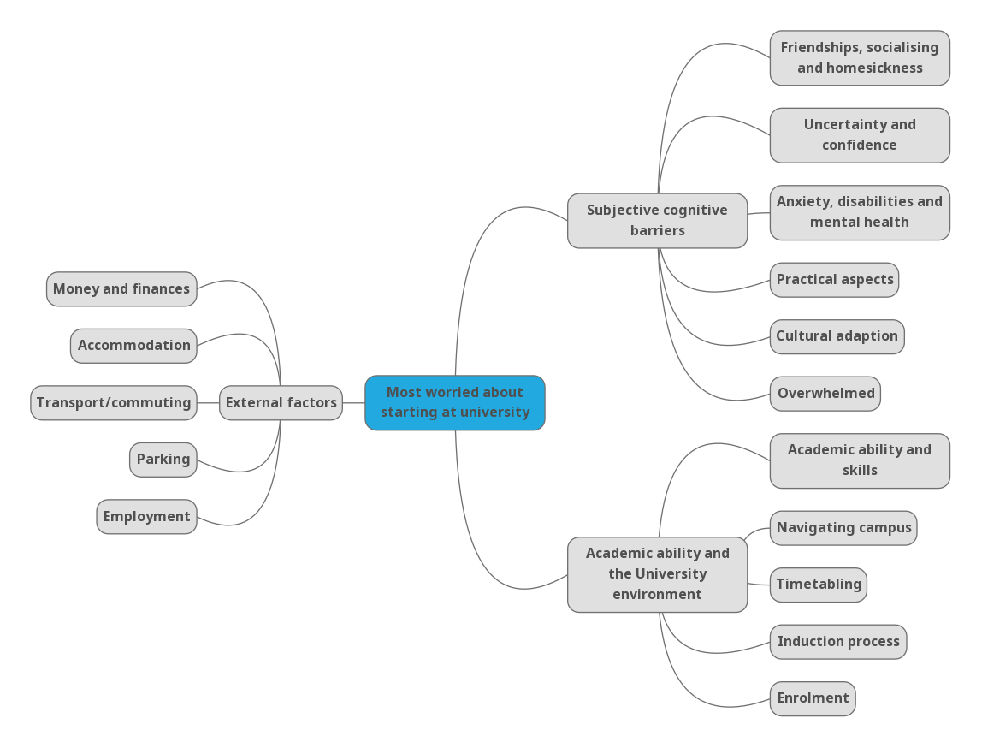

Appendix 1: Demographic overview of respondents
Ethnicity
White | 47.48%
BAME | 46.56%
Information refused/unknown | 5.96%

Age
16-17 | 0.92%
18-21 | 66.86%
22-25 | 12.84%
26-30 | 5.85%
Over 30 | 13.53%

Gender
Male | 44.61%
Female | 53.90%
Other | 1.49%

Fee status
Home | 76.15%
EU | 5.28%
Overseas | 14.11%
Not known | 4.47%

School
Art, Design and Performance | 20.87%
Human and Social Sciences | 18.23%
Creative and Digital Industries | 17.09%
Health and Social Care Professions | 12.27%
Business and Law | 11.81%
Aviation and Security | 11.24%
Nursing and Midwifery | 5.62%
Engineering and the Built Environment | 2.18%
Missenden Abbey International Hotel School | 0.46%
Collaborative Provision (UK) | 0.23%

