Big Conversation 2025 analysis – supplementary analysis to the main report, specifically filtered to international students
Introduction
This summary report analyses the data collected as part of the Big Conversation filtered solely to those that are classed as international students. This report removes all data from domestic students. The report also includes data from the Big Conversation held across all campuses in September/October along with the January intake of students.
Filtering out domestic students, this reduces the sample size to 549 which represents 34.23% of the total sample (n = 1,604).
Appendix one provides a demographic breakdown of the sample size.
Analysis of initial questions
Q2. Did you know that you are a member of the Students’ Union?
Yes | 53.92%
No | 46.08%
Base (all respondents): 549
Q3. Have you heard about the Big Deal?
Yes | 41.17%
No | 58.83%
Base (all respondents): 549
Analysis of open comments
Question four captured insights into what students were most looking forward to at university.
On analysing the data, several students responded to this question with an ‘unsure’ response or gave no answer. Filtering out these non-responses, leaves a cleaned total of 463 responses to this question.
Conducting a thematic analysis of the data, the following themes emerged (note that these are slightly realigned for this specific analysis and vary ever so slightly to the wider Big Conversation report):
- The degree, learning and the University environment
- The Students’ Union and co-curricular activities
- Socialising, friendships and having fun
- New experiences, cultures, exploring and networking
- Skills for the future, careers and achieving goals
The degree, learning and the University environment
This was the largest theme with 224 (48%) responses, covering the degree, learning and the University environment. This theme is in line with the wider Big Conversation report where it was the most commonly raised topic from discussions.
Most of the responses that fall into this theme were course-related and included the course, studying and learning. Others simply referenced getting started at university, meeting academics, getting involved or the wish to become a specialist in that subject area (e.g., “become a nurse”).
This theme also captures those that mentioned placements, completing the degree, the facilities, and the University environment.
The Students’ Union and co-curricular activities
In contrast to the wider Big Conversation report, the Students’ Union and co-curricular activities, shifted to the second most discussed topic. This theme received 120 (26%) responses.
The most commonly cited aspect of the Students’ Union was sport, societies, and activities. In fact, several students were able to specifically mention the sport or societies that they were most interested in and this varied from cricket, football, volleyball and badminton to weightlifting, Islamic Society, Baking Society and boxing.
Other students mentioned freshers’ fairs, events in The Venue, volunteering and trips. One student mentioned how the “Students’ Union is the best in the UK” with another talking about their wish in “being proactive with the SU and wanting to contribute towards the Union”.
Socialising, friendships and having fun
The third largest theme, with 99 (21%) responses, centres around the social aspect of coming to university. Most talked about meeting new people and making friends. Others talked about the ability to socialise and have fun.
New experiences, cultures, exploring and networking
The fourth largest theme, with 51 (11%) responses, focuses on the experience, cultures, exploring and networking.
Many students simply mentioned their excitement about the general/overall experience, which also encompasses those that simply mentioned everything, and where they could not pinpoint one specific aspect that they were most looking forward to. Others reference their eagerness to explore, whilst others talked about general excitement.
Within this theme, several cited their ability to experience other cultures, with one student noting how they were simply “going with the flow”.
Many students talked about their ability to network at the University and the fact that they can build new connections with other students and academic staff.
Skills for the future, careers and achieving goals
In contrast to the wider report, future career and skills has dropped to the least cited theme and received only 20 (4%) responses.
Of those that discussed topics within this theme, several mentioned general opportunities for the future, with others talking about their future. A small number talked about their career with others citing developing their skills. One student mentioned how they were looking forward to “build my communication skills” with another looking forward to achieving goals.
As a summary to this question, the below table provides the number of responses to each theme and is shown as a percentage that is the number of instances of that theme within the analysed data. This table runs in the specific order of most to least commonly cited, from data analysed on international students, and factors in a simple percentage change to the wider report that was drafted on data collected as part of the Big Conversation in October 2025.
Theme | Responses | Percentage | Change
The degree, learning and the University environment | 224 | 48.38% | +15.67%
The Students’ Union and co-curricular activities | 120 | 25.92% | +19.42%
Socialising, friendships and having fun | 99 | 21.38% | -2.3%
New experiences, cultures, exploring and networking | 51 | 11.02% | +1.63%
Skills for the future, careers and achieving goals | 20 | 4.32% | -12.94%

The above themes and sub-themes have been captured into the following thematic map (filtered to international students only). 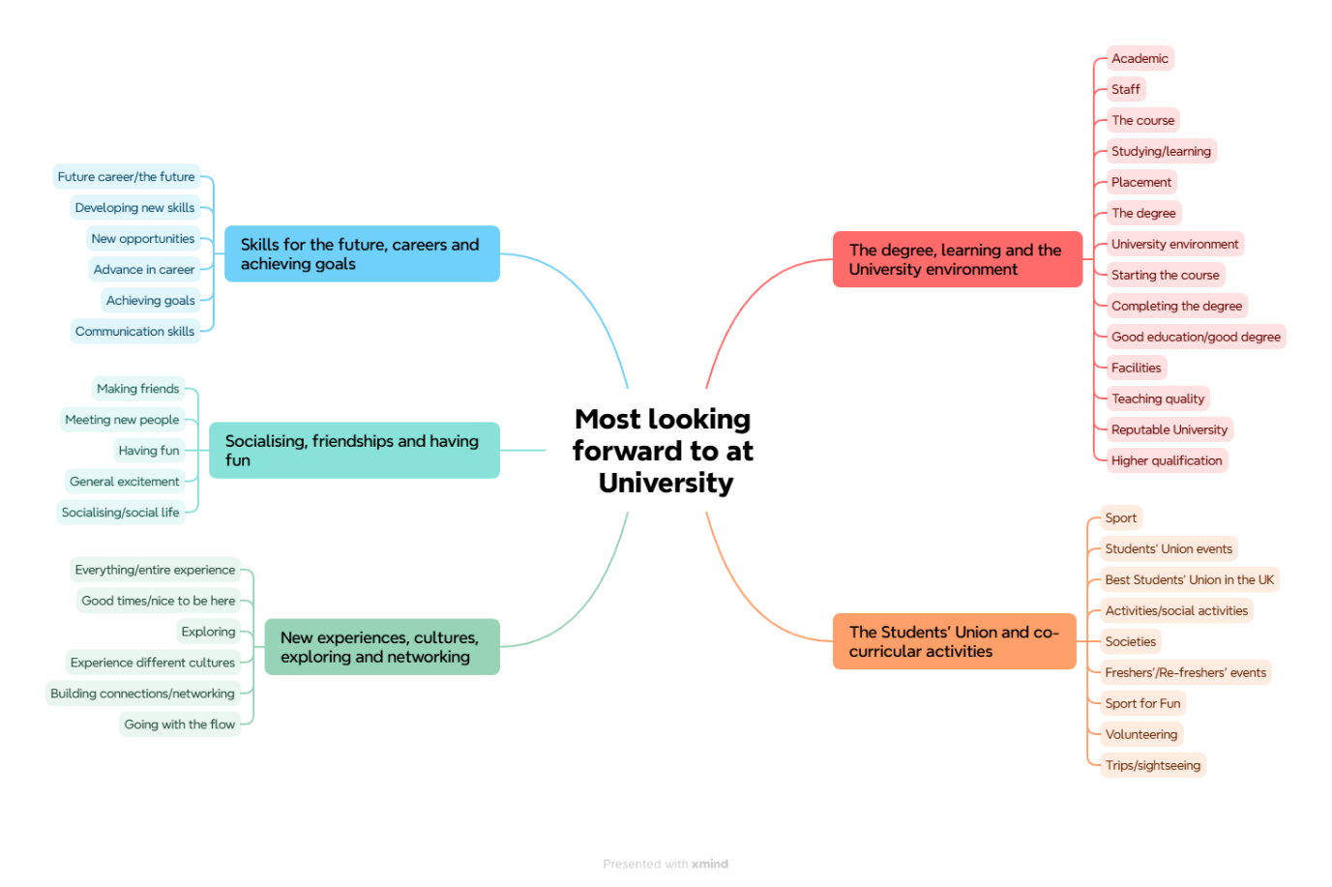

Question five captured student feedback into some of the challenges and concerns that students might have about starting university. Responses to this question were also obtained through discussions with individuals and gathered through open comments. These comments were then grouped together around common themes and sub-themes.
From the subsequent analysis, a large proportion of students noted that they had no concerns or opted to leave the question blank, to leave a total of 102 cleaned responses.
On conducting a thematic analysis of the data, the following three themes emerged (the order of themes follows suit from the wider Big Conversation report):
- Personal barriers and worries
- Academic ability and the University experience
- Other external factors
Personal barriers and worries
This theme emerged as the largest concern with personal barriers and worries being the most commonly cited issue facing students, at the point of starting university. This theme received a total of 44 (42%) responses.
The most common sub themes reference worries around making friends, not knowing anyone, homesickness and settling in. Similar to this is the concern that students have with moving to a new place, adapting to a new environment, and, in most cases as this is filtered to international students, moving to a new country. Some students mentioned language as being a potential barrier to their learning and one student mentioned their concern about not being “familiar with the British education system”. A few referenced their general anxiety and nervousness and the feeling of being overwhelmed with the amount of information provided. Some also talked about the work-life balance and the importance of striking the right level between the two.
One student described the concern of their mental health with another being worried about racism. Similarly, one student mentioned how they were “hoping for it to be a friendly environment”.
Academic ability and the University experience
The second largest theme focuses on academic ability and the wider University experience, with a total of 32 (31%) coded responses. Similar to the previous theme, the responses to this varied quite a bit which has made it difficult to create sub-themes. The most common cited issue centres around academic ability. This encompasses studying, assignments, guidance in studies and exams. A small number of students mentioned placements, with others referencing timetabling and student support. One student cited “language barriers in studying” with another stating a worry around “accessing what they need”.
Other external factors
The third largest theme focuses on other external factors, with a total of 29 (28%) coded responses. The most commonly referenced theme focuses on transport and travel/commuting from various different locations. Second to this is those trying to find part-time work. Accommodation was also mentioned by several along with other household aspects such as groceries and laundry. A very small number mentioned fees as being a top concern. It is worth mentioning that not one student mentioned money or finances as being a concern.
As a summary to this question, the below table provides the number of responses to each theme and is shown as a percentage that is the number of instances of that theme within the analysed data. This table runs in the specific order of most to least commonly cited, from data analysed on international students, and factors in a simple percentage change to the wider report that was drafted on data collected as part of the Big Conversation in October 2025.
Theme | Responses | Percentage | Change
Personal barriers and worries | 44 | 42.31% | -1.50%
Academic ability and the University experience | 32 | 30.77% | -2.89%
Other external factors | 29 | 27.89% | +5.37%

The above themes and sub-themes have been captured into the following thematic map.
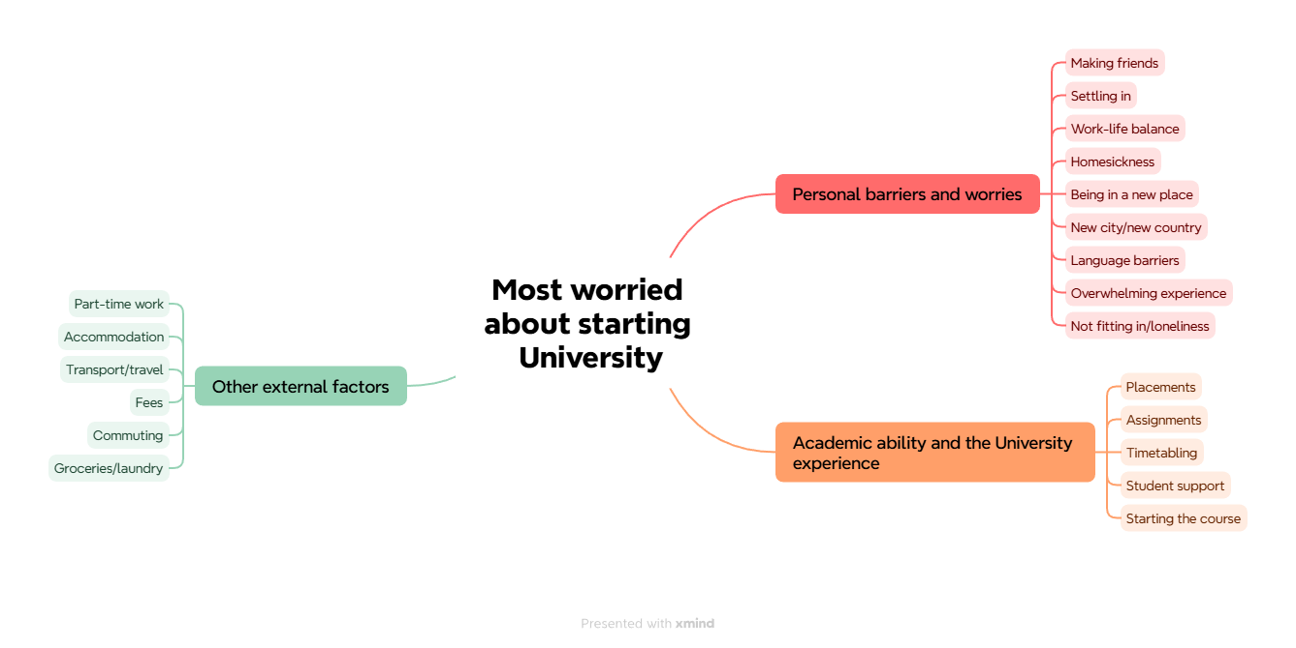
Appendix 1: Demographic overview of respondents
Ethnicity
White | 4.56%
Global majority | 82.16%
Information refused/unknown | 13.29%

Age
16-17 | 1.14%
18-21 | 38.33%
22-25 | 29.22%
26-30 | 23.72%
Over 30 | 7.59%
Gender
Male | 62.43%
Female | 37.38%
Other | 0.19%

Campus
High Wycombe | 94.12%
Uxbridge | 5.69%
Aylesbury | 0.19%

College
Leadership and Innovation | 46.49%
Health and Society | 28.46%
Creative Arts, Technology and Engineering | 25.05%

Disability
Known disability | 1.71%
No known disability | 87.67%
(no data) | 10.63%

Student type
Postgraduate | 58.25%
Undergraduate | 41.37%
Other | 0.38%

