Big Conversation 2025 analysis
Introduction
Throughout enrolment week this year, operating on a condensed period across two days, Union staff and freshers’ helpers were present to meet with new students individually to give a personal welcome to the Students’ Union and to capture some basic data.
Data captured throughout the discussions included awareness of the Students’ Union and Big Deal, prior to arrival, and to gain some basic insights into what students were most looking forward to. In contrast, we also gathered data on student concerns and to understand where some of the key challenges or concerns might lie for students.
Throughout the week, staff managed to hold a total of 1,449 conversations, which represents a drastic increase in comparison to last year (2024: 921 responses/+57.33%). As part of these discussions, staff collected student ID numbers and this data has been fed into our recording systems as a record of initial engagement with the Students’ Union (a demographic overview is included within Appendix 1). Introducing a rota for the staff team really helped us cover the Big Conversation a lot better this year with at least ten staff covering the morning and afternoon enrolment sessions. However, for future years we need to look at expanding this even further and adding around an extra five members of staff to cover the volume of students coming through.
Analysis of initial questions
At the start of the discussions, we asked students two simple questions on membership and the Big Deal with the below findings (the numbers in brackets denote the percentage differences to 2024). As there has been a continued level of growth in international students, we have looked at the membership and Big Deal questions with and without international students to determine whether this might influence findings.
Q2. Did you know that you are a member of the Students’ Union?
With international students |  | Without international students
Yes | 61.08% (-11.12%) | Yes | 64.88% (-7.32%)
No | 38.92% | No | 35.12%
Base (all respondents): 1,449/823
2024
Yes | 72.20%
No | 27.80%
Base (all respondents): 921
Q3. Have you heard about the Big Deal?
With international students |  | Without international students
Yes | 49.34% (-7.99%) | Yes | 56.99% (-0.34%)
No | 50.66% | No | 43.01%
Base (all respondents): 1,449/823
2024
Yes | 57.33%
No | 42.67%
Base (all respondents): 921
Analysis of open comments
Question four captured insights into what students were most looking forward to at university. Responses to this question were gathered through open comments, where members of the team were asked to briefly contextualise feedback from individuals. The open comments were then analysed, grouped together to identify broader themes, and then coded in a way to create sub-themes. This year, and given the fact that we had an increase in the number of students we spoke to, it has proven more complex to have a small number of themes. Therefore, the number of themes is slightly larger than in previous years and this aims to capture a broader cross-sectional perspective of the data.
On analysing the data, a number of students responded to this question with an ‘unsure’ response or gave no answer. Filtering out these non-responses, leaves a cleaned total of 1,322 responses to this question.
Conducting a thematic analysis of the data, the following themes emerged:
- The degree, academic learning and course content
- Social life, friendships and general excitement
- Skills development, learning new skills and vocational aims
- Careers and employability
- New experiences and independence
- Students’ Union and co-curricular activities
Academic learning and course content
Unsurprisingly, the largest theme, with 453 (33%) responses, covered the degree, academic learning and course content. This is in line with the findings from previous years and demonstrates one of the central aims of students coming to university. It emphasises the understanding of students wanting to study, learn and complete their degree. In many ways, this theme reflects a level of strong academic motivation.
Some students noted the “challenge” in getting their degree whilst others expressed their desire to “learn more from the course”. Some described how they want to gain knowledge and how they see the degree as a way of “expanding” this. Others described their excitement at starting the course, whilst some had their sights on completing the degree. Several students mentioned how they were looking forward to meeting academic staff with one student describing how they were looking forward to “creating a bond with staff and students”. Similarly, a number of students were able to note how they were looking forward to, and had their sights set on, graduating. Closely linked to this is the desire for students to gain a qualification and how they aspire to “get good grades”.
Within this theme, several students mentioned the University facilities and the fact that they would be using “new technology”. Others indicated their ability to network with others, including their peers and building connections with others.

Social life, friendships and general excitement
The second largest theme, with 328 (24%) responses, encompasses the more social dimension of coming to university and the ability to have a different social life and to create new friendship groups. Most responses in this theme centre around the ability for students to meet new people and the ability to make new friends. To reach this point, students noted the need to socialise with different groups of people and this can expand the number of other students those individuals can meet. A small number of students mentioned the ability to interact with other cultures and how the university environment can aid this type of cultural networking.
Several students were able to describe how they were looking forward to the entire experience and not being able to point to one individual aspect. Similarly, several students simply noted how they were looking forward to everything with a limited number suggesting how they were simply looking forward to having fun.
Skills development, learning new skills and vocational aims
The third largest theme, with 239 (17%) responses, centres around the development and building of new skills and where students are starting to think about their future. This theme has been slightly more prominent compared to last year.
Responses that fall into this theme centre around the development of skills or gaining extra/new skills. A few respondents specifically mentioned the development of IT skills whilst one student mentioned “management in leadership skills”. Similarly, several responses focused on the link between getting a degree and thinking about their vocational aims and aspirations. In many ways, students are motivated by acquiring practical and academic skills to aid their future success. A small number of students were able to describe how they see coming to university to “achieve goals”.
Careers and employability
The fourth largest theme, with 145 (10%) responses, features careers and employability and where students understand that university is seen as a pathway to job and career progression. Some students articulated this by suggesting they see their degree as an “advance in career” whilst others see it as a way to start a new career. One student was able to describe how the degree will build a career in a specific industry whilst another student suggested that the degree was “career prep”.
Some students were able to link the ability to gain knowledge from studying to get a job whilst others acknowledged the need to get a good degree to help secure a job.
New experiences and independence
The fifth largest theme, with 130 (9%) responses, is where students seek new experiences, independence and personal growth at university. Several students were able to suggest that they were looking forward to new experiences whilst others mentioned how they wanted to share their experience. Several students noted how coming to university was instigating a change to their lives whilst others look to it as a way to gain hands on experience. Similarly, students were able to link the change to “something different” and how it opened up a different lifestyle.
Closely linked to new experiences is the ability for students to have a degree of freedom. Some students noted how they were “looking forward to having a level of independence” whilst others noted how their student experience and independence are closely linked together.
Students’ Union and co-curricular activities
The fifth theme, with 90 (7%) responses, focused on the Students’ Union and the co-curricular experience that complements the academic side of university. This theme largely centres on the anticipation of doing activities through the Students’ Union that reflects engagement beyond studying. The vast majority of those that responded to the Students’ Union and co-curricular activities mentioned that they want to join a sport team or society. A number of students were able to specifically mention the society or sports team that they wished to join, possibly indicating that they had previously researched which ones we had available, prior to arrival, or by looking at our summer communications. A few students were able to cite other parts of our offer, and these included: Sport for Fun, volunteering and recreational activities.
Several students mentioned Freshers’ Fortnight and were able to reference specific events that they wanted to attend. Others suggested the social aspect of attending events in The Venue and the ability of being able to meet new people.
A number of students were able to cite other examples of co-curricular activities to help balance their academic studies, with the most commonly mentioned topic being the gym. Similarly, a small number of students mentioned general fitness with one student noting how they wanted to get involved in “community service”.
As a summary to this question, the below table provides the number of responses to each theme and a percentage that is roughly the number of instances of that theme within all data collected.
Theme | Responses | Percentage
The degree, academic learning and course content | 453 | 32.71%
Social life, friendships and general excitement | 328 | 23.68%
Skills development, learning new skills and vocational aims | 239 | 17.26%
Careers and employability | 145 | 10.47%
New experiences and independence | 130 | 9.39%
Students’ Union and co-curricular activities | 90 | 6.50%

The above themes and sub-themes have been captured into the following thematic map.
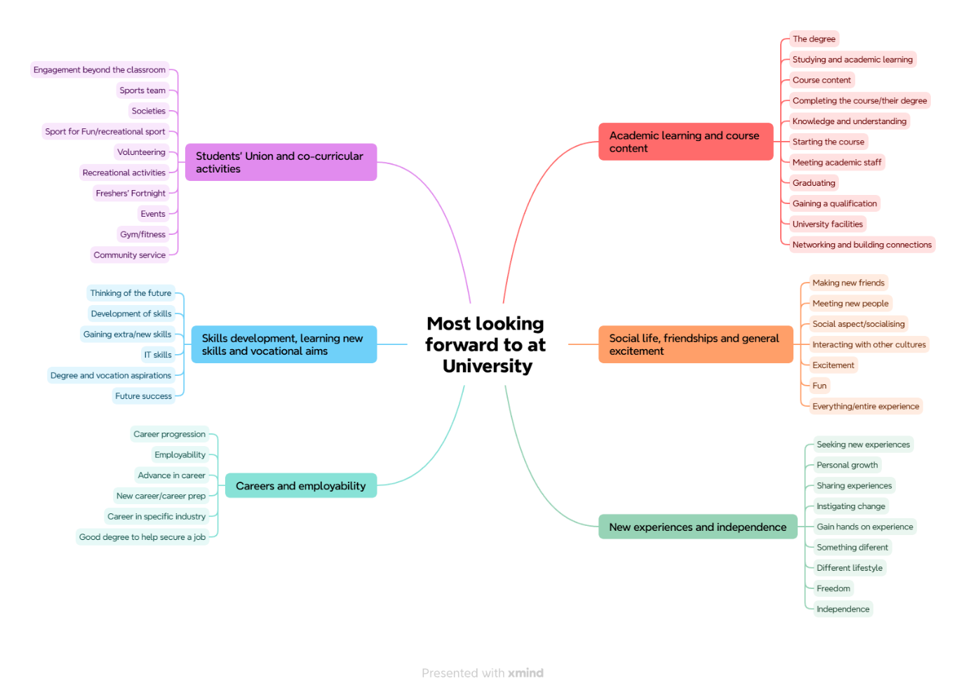

Question five captured student feedback into some of the challenges and concerns that students might have about starting university. Responses to this question were also obtained through discussions with individuals and gathered through open comments. These comments were then grouped together around common themes and sub-themes.
From the subsequent analysis, a large proportion of students noted that they had no concerns or opted to leave the question blank, to leave a total of 404 cleaned responses.
On conducting a thematic analysis of the data, the following three themes emerged:
- Personal barriers and worries
- Academic ability and the University environment
- External factors
Personal barriers and worries
Unsurprisingly, this theme emerged at the largest with the biggest concern facing students and their own personal worries and barriers to starting university. This theme was coded with a total of 177 (44%) coded responses. The strongest sub-theme within this theme centres on friendships and the relationships that need to be formed with new people. Although a number of students cite meeting new people and making new friends as one of the aspects they are most looking forward to, equally, this is also a perceived barrier that people are most concerned about when starting university. Secondary to this is the notion of social integration and the ability to socialise with others and this is another commonly reference sub-theme, or, as one student suggests “fitting in with the social aspect.” A limited number of students mentioned the fact that it was the first time living on their own and the level of independence this provides. Although several students suggested that this was a positive factor, equally, several see it as a negative where there is a degree of apprehension and the ability to live on your own.
In strong parallels to making new friends is the worry about students feeling lonely or their concerns about not fitting in. In fact, some students cited the fact that they were worried about the volume of information and how it might be “too much information to process” or the general feeling of being completely overwhelmed with everything. Although we provide a lot of support to students across the first few weeks of term, it can still be daunting and the pressure that students can feel to settle in quickly. All these factors can contribute to students feeling homesick and the anxieties that can come with moving to a new environment and “getting used to something new.” One student was able to describe how starting university is a “very big change”.
Several students cited an ongoing disability as a concern that they perceived might have an impact on their ability to settle in. Some students mentioned specific disabilities (e.g., dyslexia and neurodivergence), whilst others mentioned broader learning difficulties. In fact, the student that mentioned neurodivergent went on to cite their need to have “reasonable adjustments” in place with another specifically mentioning that they needed to speak to the University’s Disability and Inclusion Service. In comparison to previous reports, a larger proportion of students referenced age as a concern where they are older than the average (perceived) student age, or as one student suggested, “slightly worried about being a mature student.” Similarly, several students mentioned the fact that they were international and where language could be a barrier to their ability to settle in. One student mentioned how they were “a little bit nervous [and in a] new country” with a small number suggesting that their level of English could be a potential barrier.
Some students expressed their worry about striking the right university work-life balance and some even described how they were concerned about balancing childcare alongside academic commitments and the scheduling of study time. Similarly, a proportion of students mentioned their time management as a potential concern.
Academic ability and the University environment
The second largest theme focuses on academic ability and the wider University environment, with a total of 136 (34%) coded responses. By far, the most recurring sub-theme focuses on purely academic skills. Several students cited workload, coursework, assignments and lessons as their chief concerns, with others mentioning exams and writing. One student even mentioned that they “don’t know how to study, need some extra help,” whereas, another student commented on how they were “worried about [the] course not being good enough.” A proportion of students mentioned timetabling as being a concern with several others citing some form of technology as making them worry. Out of those that mentioned technology, some referenced the fact that aspects were new to them with a proportion of others mentioning IT, or, as one student mentioned how they were “worried about IT information technology, digital skills zero.”
The physical University environment was mentioned by several students with the vast majority referencing navigation, or “getting lost” as they biggest worry. Although, arguably, this could be construed as students navigating their way around the local area, it can also be linked to campus and the fact that they do not have a full understanding of halls and their respective University campus for classrooms, lecture theatres, etc. For others, placements were a recurring sub-theme with many students uncertain about where placements might be located or the fact that they are a different environment to the main campuses. Several students cited support services, or, as one student suggested, the “right support for needs.” Similarly, another student mentioned the need for “support with assignments and task management.” One student suggested their anxiety around other classmates and mentioned “not getting on with peers.”
A few students specifically talked about how they were concerned about failing with another being worried about not graduating. Similarly, a small number of students mentioned their apprehension about returning back to university and “studying again after a few years away.”
External factors
The third largest theme focuses on external factors, with a total of 91 (23%) coded responses. The analysis of this data was slightly more varied, and a lot of different topics fell into this theme. The largest sub-theme within this category focused on money and finances, more broadly. To counterbalance the potential issue with money, several students acknowledged the need to get a job and to work alongside studying. Of those that cited money as an issue, several mentioned being able to afford their rent. One student was already able to suggest that they needed to access the “hardship fund.”
Another recurring sub-theme within this section covers issues with transport. Students cited several potential issues with this and these comments largely distance to the campus, local transport, and commuting. One student was able to suggest the downside to “commuting and missing everything.” In fact, some students commented on how far they had to travel with one mentioning they commute from Birmingham. Several other students referenced parking as an issue with several commenting on the fact that there is no free parking. This is an aspect that we can try and address as a campaign to highlight the free carparking on campus.
Accommodation was a commonly mentioned factor and something that bears on the minds of students. Although this is linked to finances, one student suggested that the University accommodation was “too far away” with another student noting how they were starting a new chapter in their life, in a new town. Linked more broadly to learning more about the local area, a few students indicated their need to finding their way around locally with one student suggesting how they are “trying to find the right places.”
As a summary to this question, the below table provides the number of responses to each theme and a percentage that is roughly the number of instances of that theme within all data collected.
Theme | Responses | Percentage
Personal barriers and worries | 177 | 43.81%
Academic ability and the University environment | 136 | 33.66%
External factors | 91 | 22.52%

The above themes and sub-themes have been captured into the following thematic map.
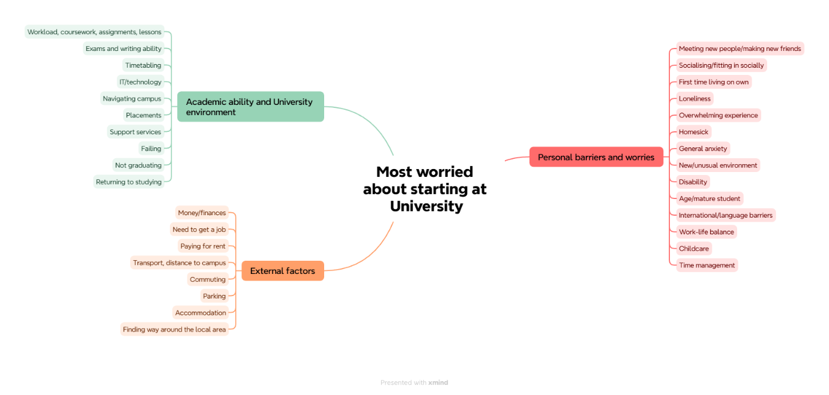

Appendix 1: Demographic overview of respondents
Ethnicity
White | 33.06%
Global majority | 60.40%
Information refused/unknown | 6.54%

Age
16-17 | 0.45%
18-21 | 53.12%
22-25 | 17.01%
26-30 | 11.59%
Over 30 | 17.83%

Gender
Male | 46.95%
Female | 51.19%
Other | 1.86%

Fee status
Home | 67.38%
EU | 2.30%
Overseas | 30.09%
Not known | 0.22%

Mode of study
Full-time | 97.62%
Part-time | 1.19%
Part-time apprentice | 1.19%

School
Health and Society | 42.20%
Creative Arts, Technology and Engineering | 29.79%
Leadership and Innovation | 27.41%
Others (partners) | 0.57%

